Austin Harvey

CST-221

Unix Family of Operating Systems

September 20th, 2020

|  |  |  |
| --- | --- | --- |
| 1 | whoamI |  |
| 2 | Users |  |
| 3 | ls (ls -a, ls – color, ls -f) |  |
| 4 | Chmod r,w,x permissions (took out ability to read file): |  |
| 5 | Check the value of any 3 environmental variables |  |
| 6 | File Directory for searching commands |  |
| 7 | Find specific content in file directory with grep, sort, and piping commands |  |
| 8 | **Exploring super user (root) account:** |  |

**The super user** is a special user account in Linux used for system administration. It has the highest privilege a user can have on Linux and can access all commands and files. Super users can log into their account from the Linux terminal by typing in the command “sudo -i” or Super users will want to use their account when they want to manage other user accounts, install new software, and change file ownership.

5 useful/distinct Linux commands:

|  |  |  |
| --- | --- | --- |
| 1 | pwd command tells you the working directory path |  |
| 2 | cat command will print out content of file in exact format it was written in. |  |
| 3 | touch command will create the file name and type inputted. |  |
| 4 | history command to view all commands used on Linux. |  |
| 5 | Top command displays all running processes. This is useful to monitor system resource usage and terminate overusing CPU. |  |

Test.sh Results (commands are whoami, users, ls -a, pwd, df):

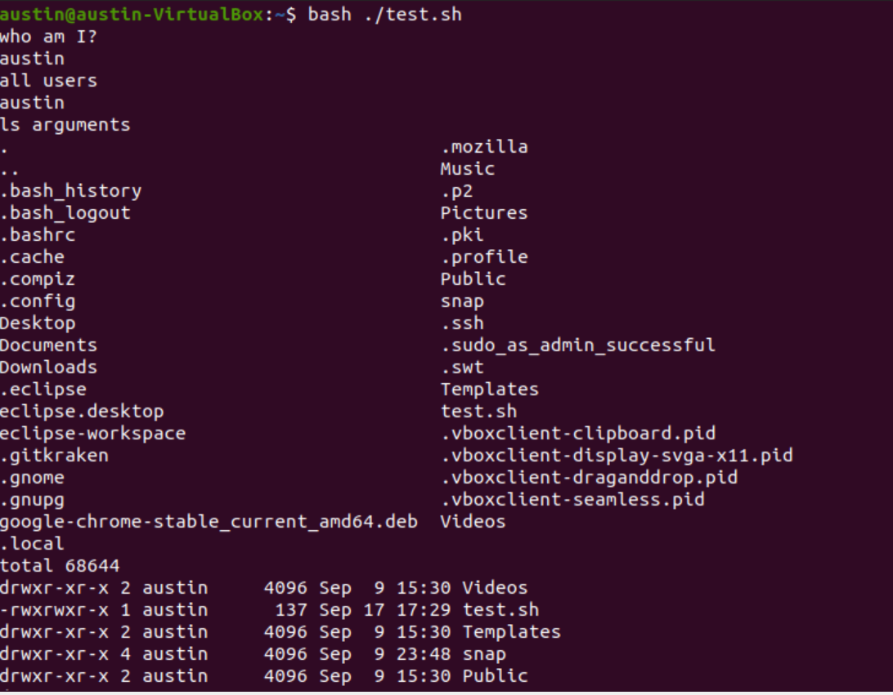

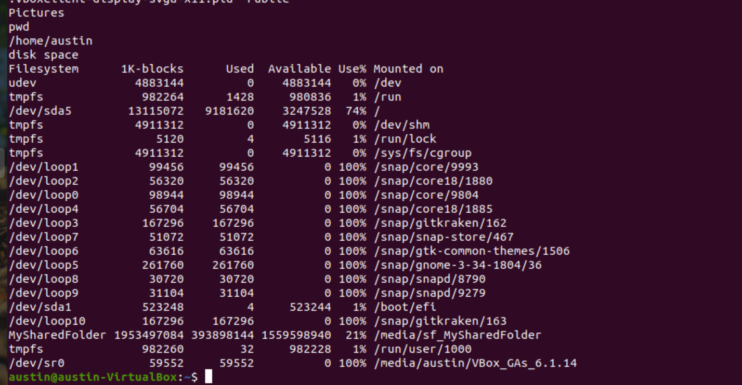

Resources:

<https://files.fosswire.com/2007/08/fwunixref.pdf>

<https://www.digitalocean.com/community/tutorials/how-to-read-and-set-environmental-and-shell-variables-on-a-linux-vps>

<https://www.howtogeek.com/412055/37-important-linux-commands-you-should-know/>